**ROSHNI RAZA**

**SAP :**

**LAB 05**

TASK 1:

#include <iostream>

using namespace std;

struct Node

{

int data;

Node *next;

Node *prev;

};

Node *head =NULL;

void insert(int n)

{

Node *newNode = new Node;

newNode-> data = n;

newNode-> next = head;

newNode-> prev = NULL;

if ( head!=NULL)

{

head->prev =newNode;

}

head = newNode;

}

void print()

{

cout<<"data elements in the list are:";

Node *temp = head;

while ( temp!=NULL)

{

cout<<temp->data<<" ";

temp = temp -> next;

}

}

void DeleteAtBeginning()

{

if( head== NULL)

{

cout<<" the list is empty:";

return;

}

Node * temp= head;

head = head->next;

if( head!= NULL)

{

head-> prev = NULL;

}

delete temp;

}

int main()

{

insert(5);

insert(4);

insert(3);

insert(2);

insert(1);

print();

DeleteAtBeginning();

print();

return 0;

}

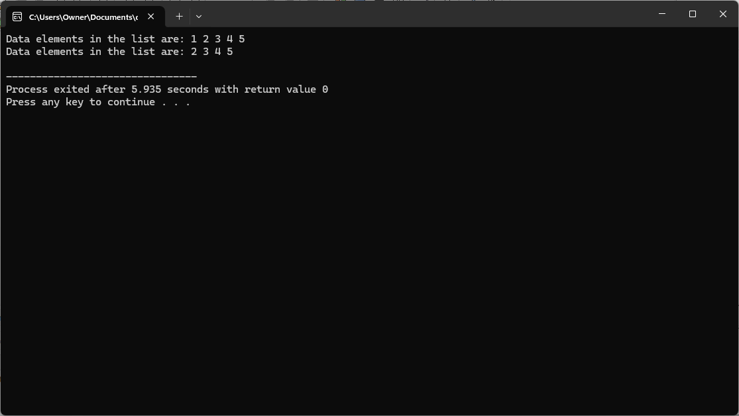

TASK 2:

#include <iostream>

using namespace std;

struct Node {

int data;

Node *next;

Node *prev;

};

Node *head = NULL;

void insert(int n) {

Node *newNode = new Node;

newNode->data = n;

newNode->next = head;

newNode->prev = NULL;

if (head != NULL) {

head->prev = newNode;

}

head = newNode;

}

void print() {

cout << "Data elements in the list are: ";

Node *temp = head;

while (temp != NULL) {

cout << temp->data << " ";

temp = temp->next;

}

}

void deleteAtSpecificPoint(int pos) {

if (head == NULL) {

cout << "The list is empty.";

return;

}

if (pos == 0) {

Node *temp = head;

head = head->next;

if (head != NULL) {

head->prev = NULL;

}

delete temp;

return;

}

Node *temp = head;

for (int i = 0; i < pos - 1; i++) {

temp = temp->next;

}

if (temp->next == NULL) {

return;

}

Node *nodeToDelete = temp->next;

temp->next = nodeToDelete->next;

if (nodeToDelete->next != NULL) {

nodeToDelete->next->prev = temp;

}

delete nodeToDelete;

}

int main() {

insert(5);

insert(4);

insert(3);

insert(2);

insert(1);

print();

cout << endl;

deleteAtSpecificPoint(2);

print();

return 0;

}

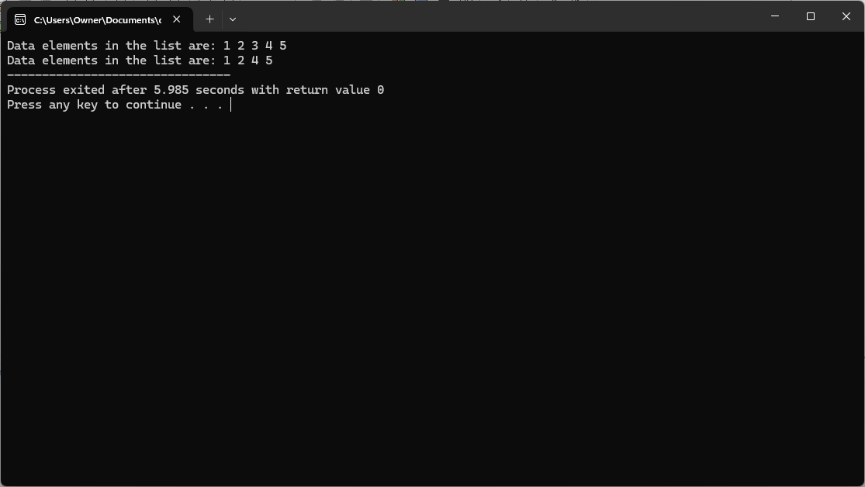

TASK 3:

#include <iostream>

using namespace std;

struct Node {

int data;

Node* next;

};

Node* head = NULL;

void insert(int n) {

Node* newNode = new Node;

newNode->data = n;

newNode->next = head;

head = newNode;

}

void print() {

cout << "Data elements in the list are: ";

Node* temp = head;

while (temp != NULL) {

cout << temp->data << " ";

temp = temp->next;

}

cout << endl;

}

void deleteAtEnd() {

if (head == NULL) {

cout << "The list is empty." << endl;

return;

}

if (head->next == NULL) {

delete head;

head = NULL;

return;

}

Node* temp = head;

while (temp->next->next != NULL) {

temp = temp->next;

}

delete temp->next;

temp->next = NULL;

}

int main() {

insert(5);

insert(4);

insert(3);

insert(2);

insert(1);

print();

deleteAtEnd();

print();

    return 0;

}

